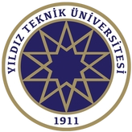
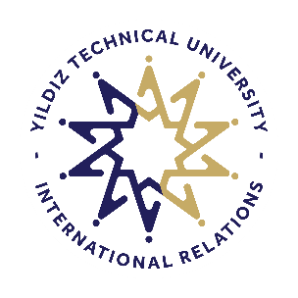
YILDIZ TEKNİK ÜNİVERSİTESİ

SCHOLARSHIP CERTIFICATE

To whom it may concern

This is to certify that the following has been accepted to carry out an Erasmus mobility at Yıldız Technical University (TR ISTANBU07) within the framework Erasmus+ Program and will receive full scholarship for the complete duration of stay.

Name
First name
Nationality
Date of birth
ID/Passport number
Home University/Country
Host University/Country
Faculty/Department
Mobility Type | ☐ Student mobility for studies (SMS)  ☐ Student mobility for training (SMT)  ☐ Staff mobility for teaching assignments (STA)  ☐ Staff mobility for training (STT)
Mobility Period | 3 October 2022-27 January 2023  ☐ Fall ☐ Spring ☐ Summer ☐ Full Year
Individual Support per month | Euro
Travel support for round trip | Euro
Project number

Yours sincerely,

